Assignment 2 Report

* Network topology diagram: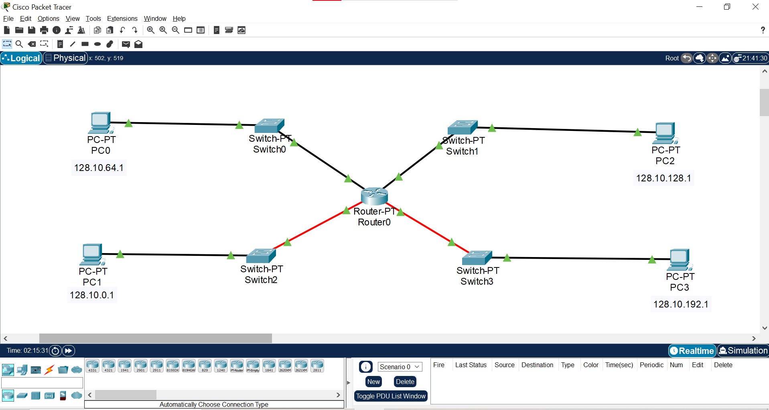
* IP addresses and network subnets ranges

PC-0 – 128.10.64.1

PC-1 – 128.10.0.1

PC-2 – 128.10.128.1

PC-3 – 128.10.192.1

Subnet mask – 255.255.192.0

Network address – 128.10.0.0

Network mask – 255.255.0.0 (class B)

* Router configuration settings

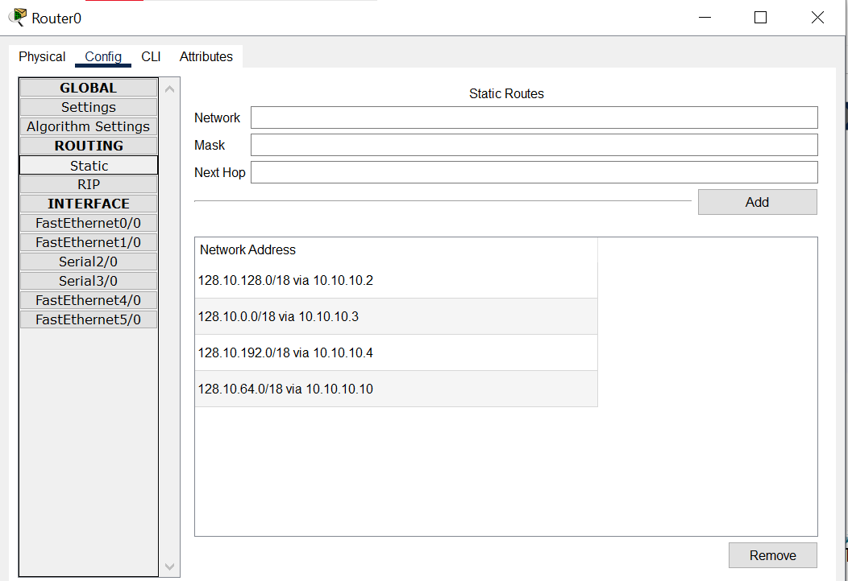

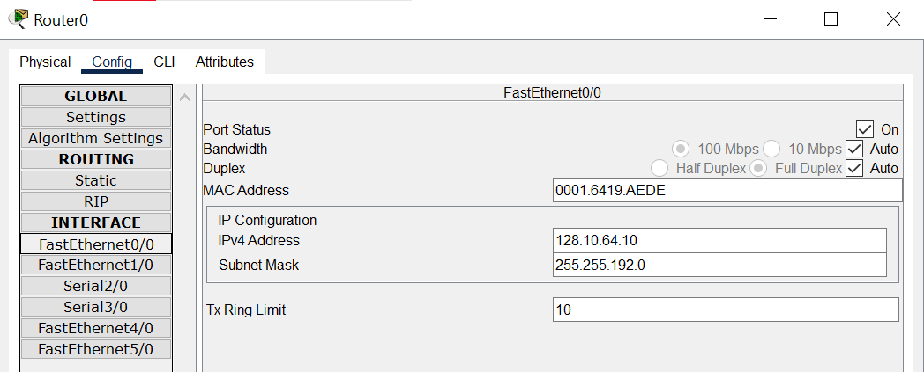

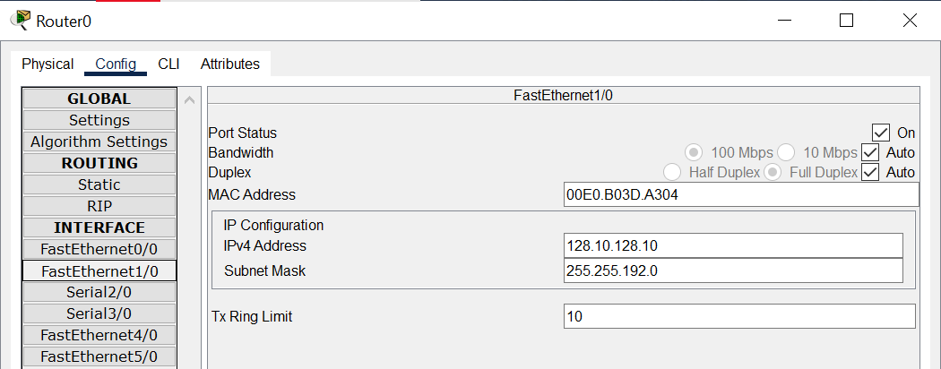

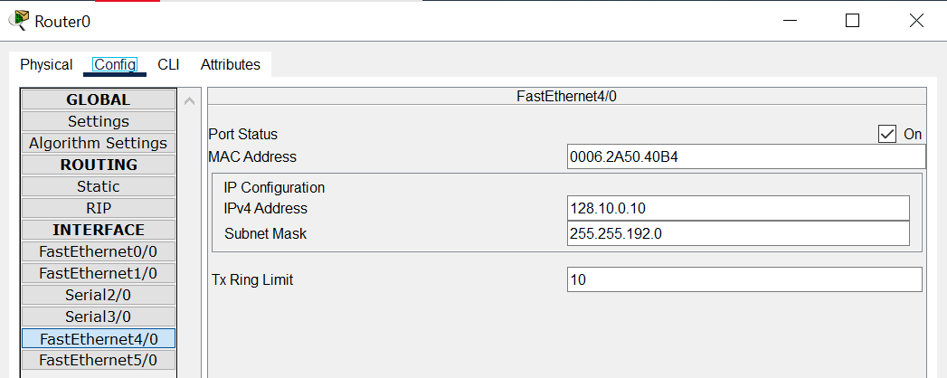

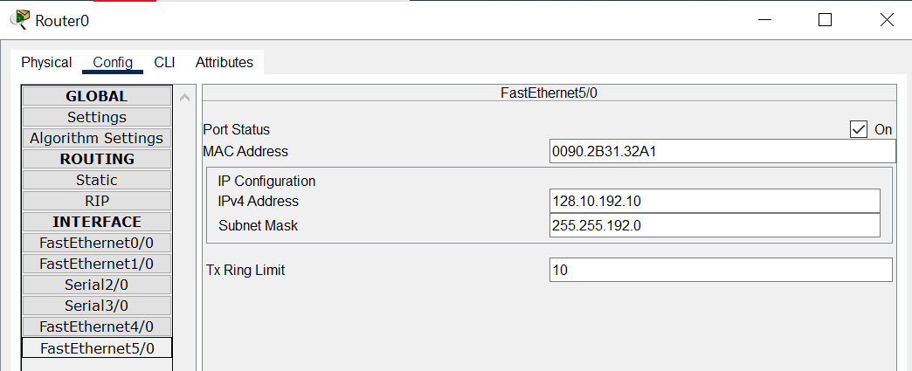

* PC configuration settings

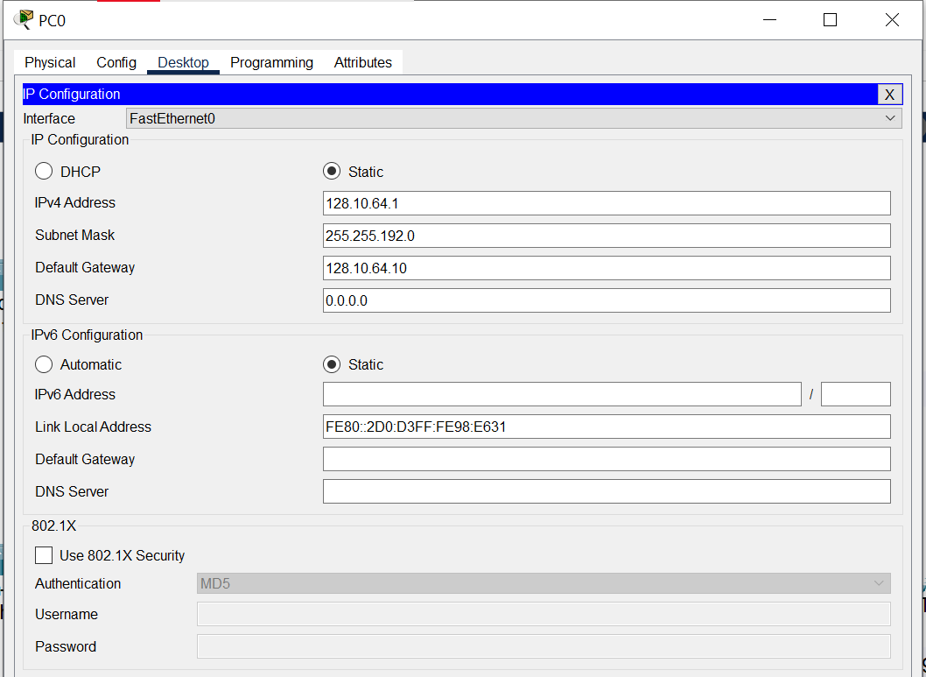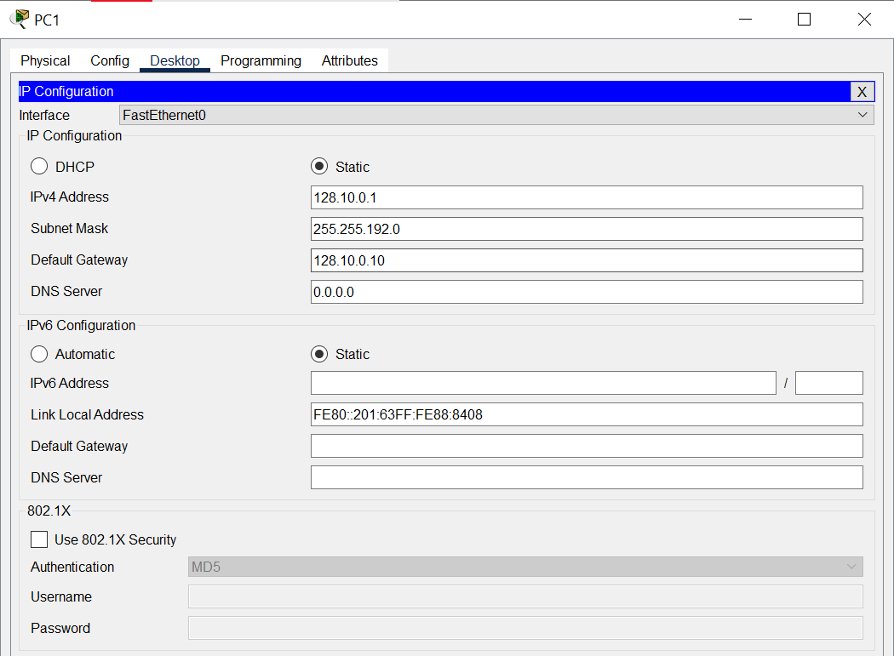

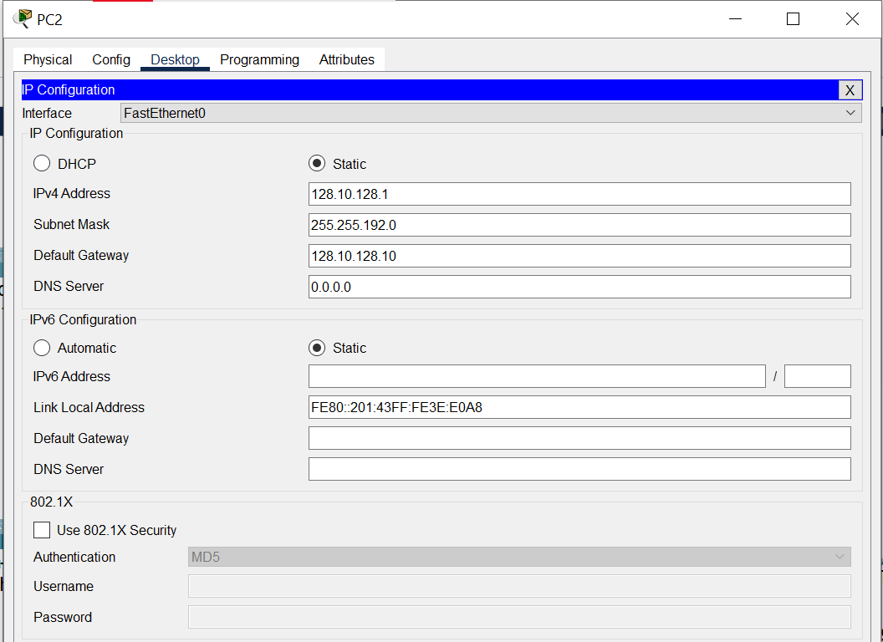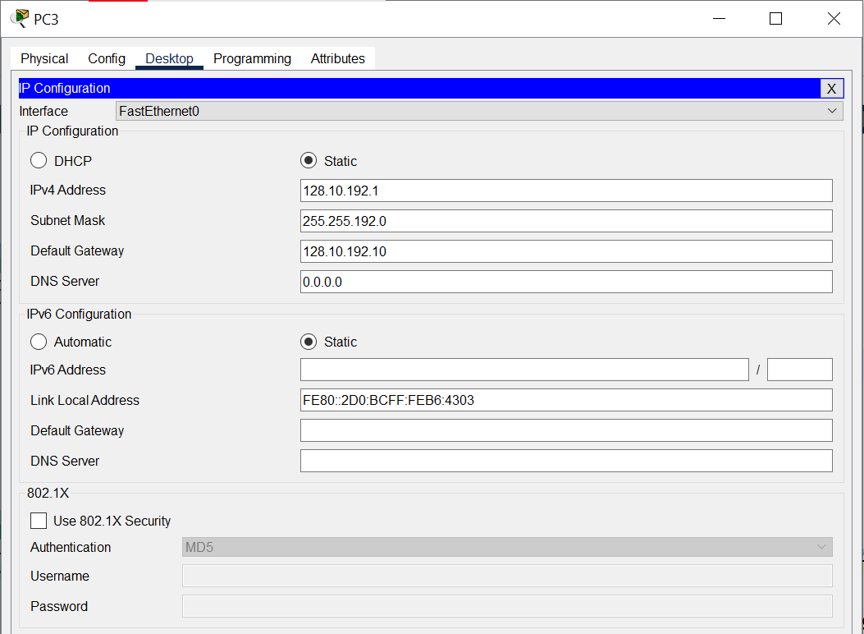

* Testing results

